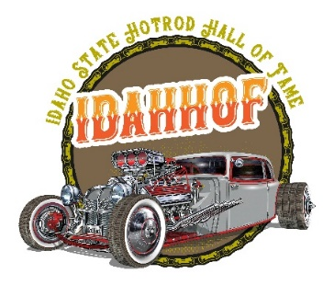

Idaho Hotrod Hall of Fame Nomination form
Please fill out the entire form. You may add anything you think is also relevant. Make sure to spell the nominees name correctly and include a jacket size in case the person is inducted! The person doesn't need to have all of these requirements. Any additional information is helpful. If you are nominating a Car Club, Give the name of the Club and all pertinent details.

Name of nominee/club ___________________________________________
Jacket size _________ (for single nominee only)
What is this person or club's connection to the hot rod community?

Does the nominee promote car shows? Sponsor car shows? Work behind the scenes?

Detail any volunteer work or functions

Does he/she write books or magazine articles about hotrods or the hot rod community?

Has he/she or club been involved in racing or racing events?

Is the person active in a car club? Give the club name and details.

What are the key club activities that benefit hotrodding in Idaho?

We would like to know not only what the person/club does for the hot rod community, but also how they give back to the community they live in.

Do they donate to charities or perhaps donate time and knowledge or experience to others?

What, if any, events or charities does the person/club support or produce?

What makes that person or club shine?

Once your nomination is completed, please email it to Brady Wright brady.wright500@gmail.com or to IDAHHOF@gmail.com

